Best Practices and Guidelines for using SafeAssign

What is SafeAssign?

SafeAssign is a powerful tool that can be enabled in blackboard courses to check the originality of papers submitted by students. It can also be used as an educational tool to help students correctly attribute their sources.

SafeAssign compares submitted assignments against a set of academic papers to identify areas of overlap between the submitted assignment and existing works.

Submissions are compared against several databases:
- Internet
- Institutional database: Contains all papers submitted to SafeAssign by JIBC students. The server is in US.
- Global Reference Database: to prevent cross-institution plagiarism.

We are only submitting JIBC student assignments to the Institutional database. We are not submitting any assignments to the Global database. However we are comparing the submissions against the both databases for originality.

These database servers are outside of Canada, currently in the United States.
FIPPA (Freedom of Information and Protection of Privacy Act): B.C. privacy law prohibits instructors/institutions from directly entering student information on a system that stores and provides access to personal information outside Canada.

Let the Students know that:
- They should submit assignments as they normally would in Blackboard, but there will be instructions that remind them that their assignment is going to be analysed by SafeAssign. Depending on how the settings have been activated by the instructor, they may or may not see the report generated by SafeAssign.
- Students should remove any identifying information (name, student number) and save their file from Word or NotePad as a .txt file (note that this will strip formatting) or use Write Submission option.
- Students should not include a cover page with their real name on it or student number. No identifying information should be included in the document.
- If using Write Submission, students create the assignment document in their preferred tool, save onto their local drive, then cut and paste into the Write Submission section.

What you need to do in order to be FIPPA Compliant:

- State the intent to use Blackboard SafeAssign in your course outline (see boilerplate below), thereby making it a course requirement, and explain that the consequence of declining to use Blackboard SafeAssign could result in being unable to complete the course. NB: If a student has a serious, principled objection to using Blackboard SafeAssign, the instructor has the discretion to offer an alternative process to the student. Students must, however, give adequate notice and reason for their objection.
- Use Blackboard SafeAssign only for a course and not personal use (e.g., submitting an article that you are peer reviewing).
- Refrain from uploading student data directly to the Blackboard SafeAssign system. Instructors may only submit student work directly to Blackboard SafeAssign that has all student identifying information removed (i.e., name, student ID number, etc.: see instructions below).
- In the event that the instructor wants to download and print a paper copy of the submission, remember that you will need to name the file and associate it with the student submitting it in some way. eg. JSmith.doc
If you are downloading all the assignments at once you need a list of pseudonyms.

Recommended Boilerplate for Course Outlines

Written work for this course will be submitted via Blackboard SafeAssign, a third party service licensed for use by JIBC. Blackboard SafeAssign is used for originality checking to help detect plagiarism. Students are not required to create an account with Blackboard SafeAssign, but their work may be submitted to SafeAssign, under the terms of the Blackboard SafeAssign terms of use agreement (http://www.blackboard.com/legal/cookies-privacy-safeassign.aspx). This agreement includes the retention of your submitted work as part of the Blackboard SafeAssign database. Any student with a concern about using the Blackboard SafeAssign service must notify the instructor at least two weeks in advance of any submission deadline.

How to locate the SafeAssign report after submission
- Instructors will access the submission to be graded

Control Panel>Course Tools>SafeAssign>SafeAssign Items>View Submissions> Click on the Checkmark
Control Panel>Grade Centre>Needs Grading OR
Control Panel>Grade Centre and selecting the assignment itself per student and will see something similar to the following:

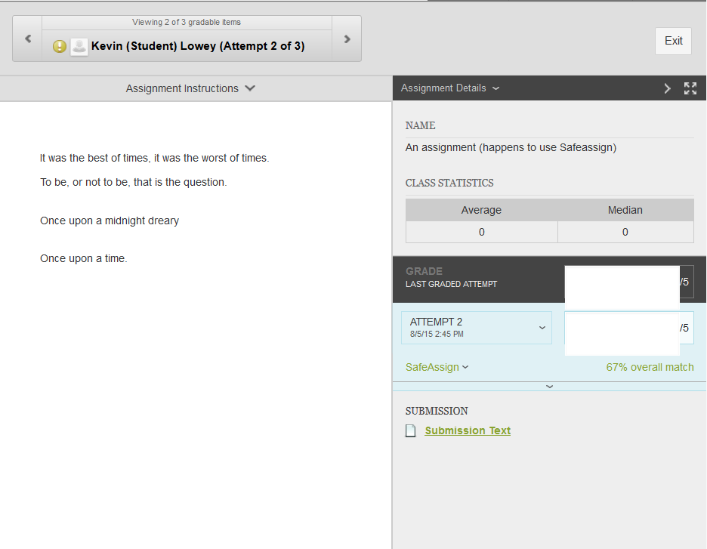
- Click on the “SafeAssign” link to expand the SafeAssign section.
- Click the “View Originality Report” button to see the originality report.

Review and understand the SafeAssign originality Report
Blackboard will provide an overall matching percentage for the assignment. This matching percentage is intended to show the instructor the percent chance that the paper contains matches to existing sources. For example, if a paper shows up with an overall matching percentage of 55%, SafeAssign is communicating that this paper has a 55% chance of containing plagiarized content. The higher the number, the more material was identified as originating in another document.

Note that this could be properly referenced material, SafeAssign does not identify if material was properly referenced or not. Just that it has material in common with another document.

The overall SafeAssign score is a warning indicator only - you will need to examine papers to determine whether the matches indicate plagiarism, or are appropriately cited.
The Safe Assign column will either be a dash if the originality report has not returned yet, or the checkmark image if the report has been completed. For completed reports, you also get a percentage matching to indicate how much of the text matched other documents.
Here are Blackboard's recommendations for interpreting overall SafeAssign scores:
- Scores below 15%: These papers typically include some quotes and a few common phrases or blocks of text that match other documents. Typically, these papers do not require further analysis as there is no evidence of plagiarism.
- Scores between 15% and 40%: These papers include extensive quoted or paraphrased material, or they may include plagiarism. Examine these papers to determine if the matching text is properly referenced.
- Scores over 40%: These papers have a very high probability of containing plagiarized content. These papers include quoted or paraphrased text in excess, and need to be examined for plagiarism.

Report layout

A SafeAssign originality report is divided into three areas:
- Report information
- Citations
- Manuscript text
If you need more remove for viewing the paper's text, you can collapse the right panel with the right-pointing arrow. The highlighting colors remain in the collapsed view.

Report information
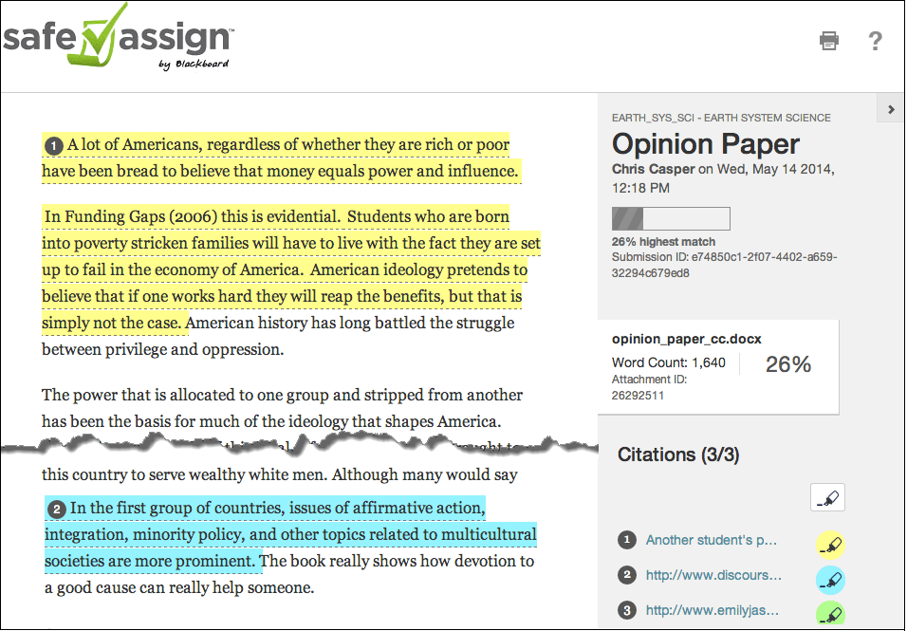
Report information appears in the right panel of the report. When you reduce the width of the viewing area, this information appears at the top. You can view data about the paper, such as the percent of matching text, word count, and when it was submitted. If you included multiple attachments, they appear with the report information. You also have an option for viewing a printable version. This printable version is the most effective view of the report for users who rely on assistive technology to access Blackboard Learn. At the top of the page, select Print to view the printable version. Download the PDF to email to others.

Citations
The sources that include text that matches the submitted paper's text are listed in the right panel of the report.

Manuscript text
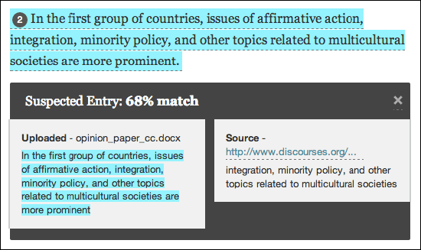
The submitted paper appears in the left panel of the report. All matching blocks of text are identified. Each source has a color specific to the source-up to 30 unique colors for 30 different sources. Text matching a source is highlighted in the source color and identified with a number. In the right panel, you can select Show/Hide All Highlighting to turn source highlighting off and on for all sources at one time. You can turn the highlighting off and on for only one citation. Select Remove or Show Highlighting next to a citation.
Select a matching block of text to display information about the original source and the probability that the block or sentence was copied from the source.

